ELECTRONICS CLUB PROJECTS:

NEWORKING PROJECTS

PROJECT 1:Make Your Own GPS Transmitter with the HC-12 Transceiver:-

This project can be used for creating a pearsonal GPS tracker by using HC-12 transceiver, a GPS module, an Arduino, and Google Maps.This project uses HC-12 to create long distance data transmission between two Arduino Unos.

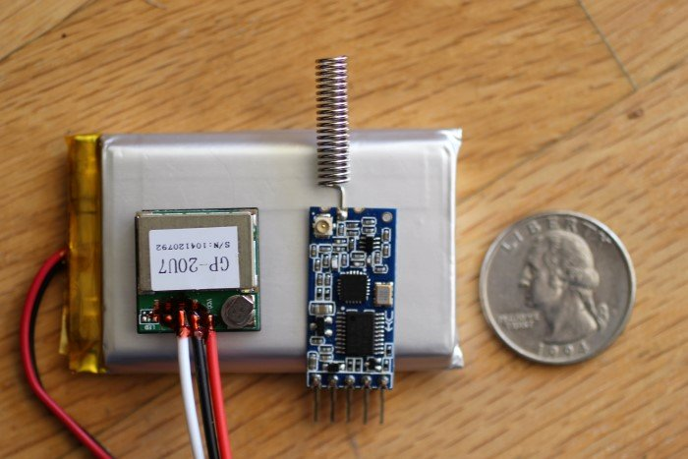

It is simple project that can be used for tracking of another small objects .It will alert you as you leaves a specified area. and then you will have a certain amount of time to track the object before the transmitter goes out of range. It can be used with a vehicle, a pet, or even—if you are concerned about theft—the giant pumpkin that you are growing for the state fair.It is like you forgot your luggage inside a train and someone(the device ) is reminding you for your luggage

In this project the message(or data ) from gps receiver is first passed aurdino with GPS logger shield and then passed to HC-12 this refines the signal in such a way that only selected data is to be passed by this we can increase the range of communication .